**GitHubProject**

# Installation

1. Install nodejs. download from https://nodejs.org/en/
2. Extract this project in your drive
3. Navigate command prompt or terminal to the extracted folder
4. Run below commands
   1. npm install gulp -g
   2. npm install gulp-connect -g
   3. npm install
5. Run command
   1. Gulp
6. Open browser
   1. <http://localhost:3030/>

# Project Configuration

1. Sign in to your GitHub account and generate a secret key for this project. Please watch below youtube video for how to generate a github key.

<https://www.youtube.com/watch?v=RHRLSSFzPBw&t=19s>

1. Note generated key and put that key inside
   1. GitHub Project\GitHubProject\src\Constant.js

GITHUB_PRIVATE_KEY **:** ‘YOUR GENERATED KEY’

# 

# Project Details

## Repository Details

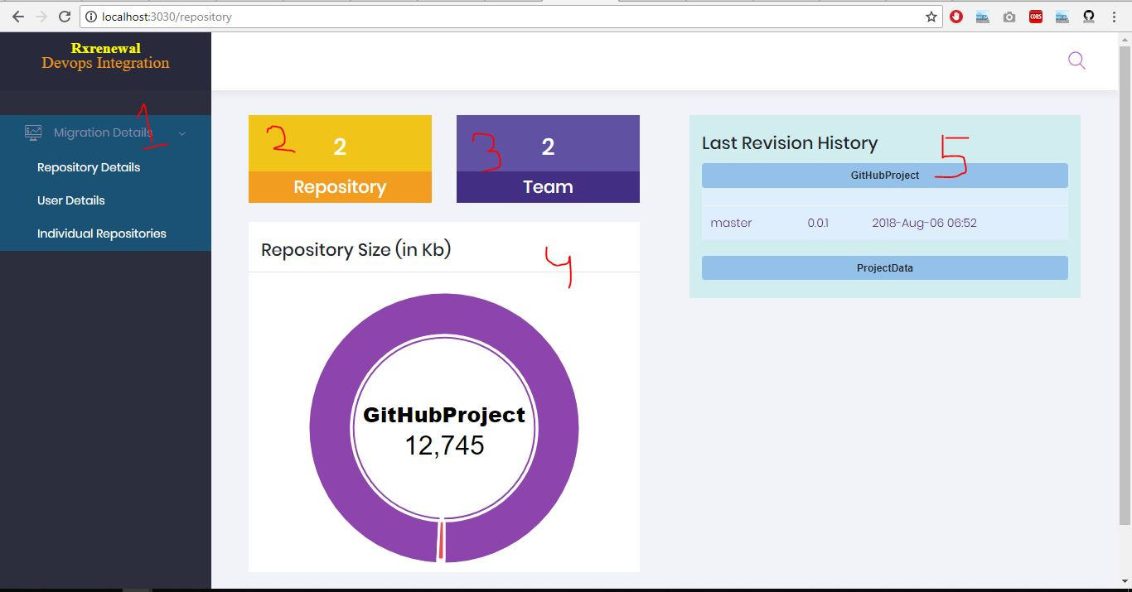

1. Side menu
2. Total numbers of repository in your organization.
3. Total numbers of teams in your organization.
4. Each repository size in KB
5. Last revision history of each repository for Master and Dev. It is a toggle button.

## User Details

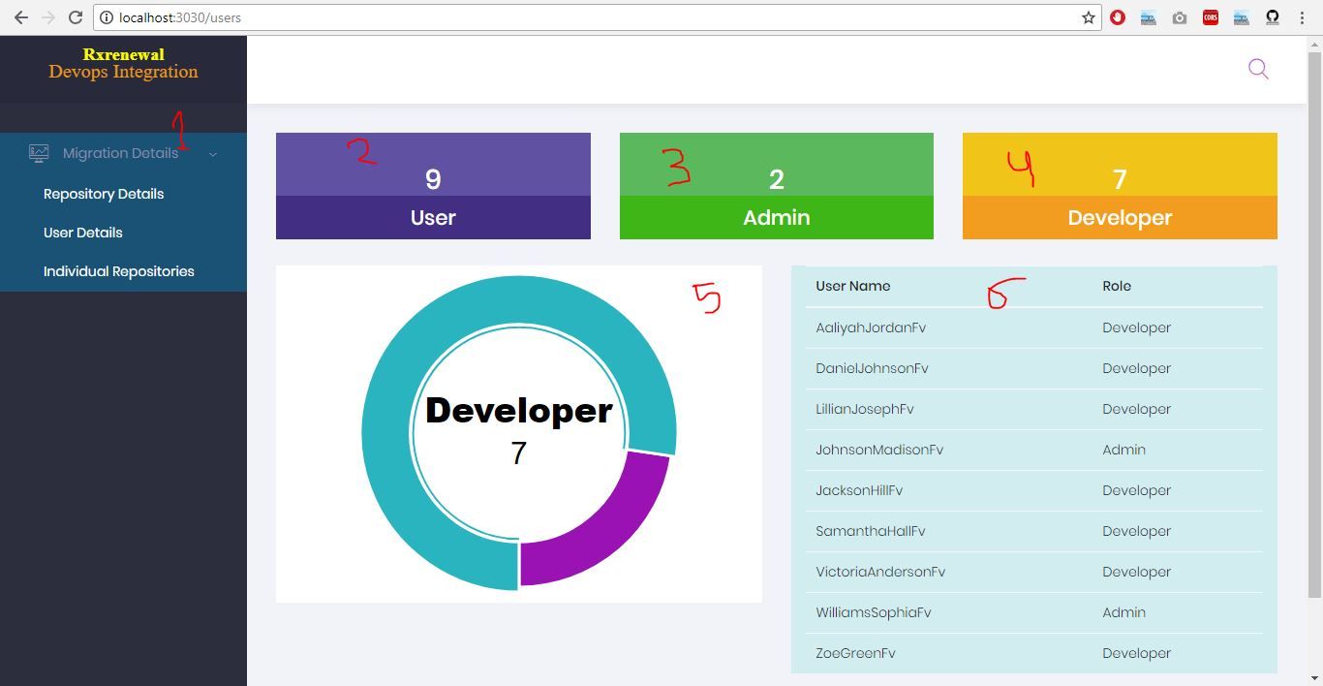

1. Side menu
2. Total numbers of user in your organization.
3. Total numbers of Admin in your organization.
4. Total numbers of Developer in your organization.
5. Pie chart for Admin and Developer.
6. List of users and their roles.

## Individual Repository

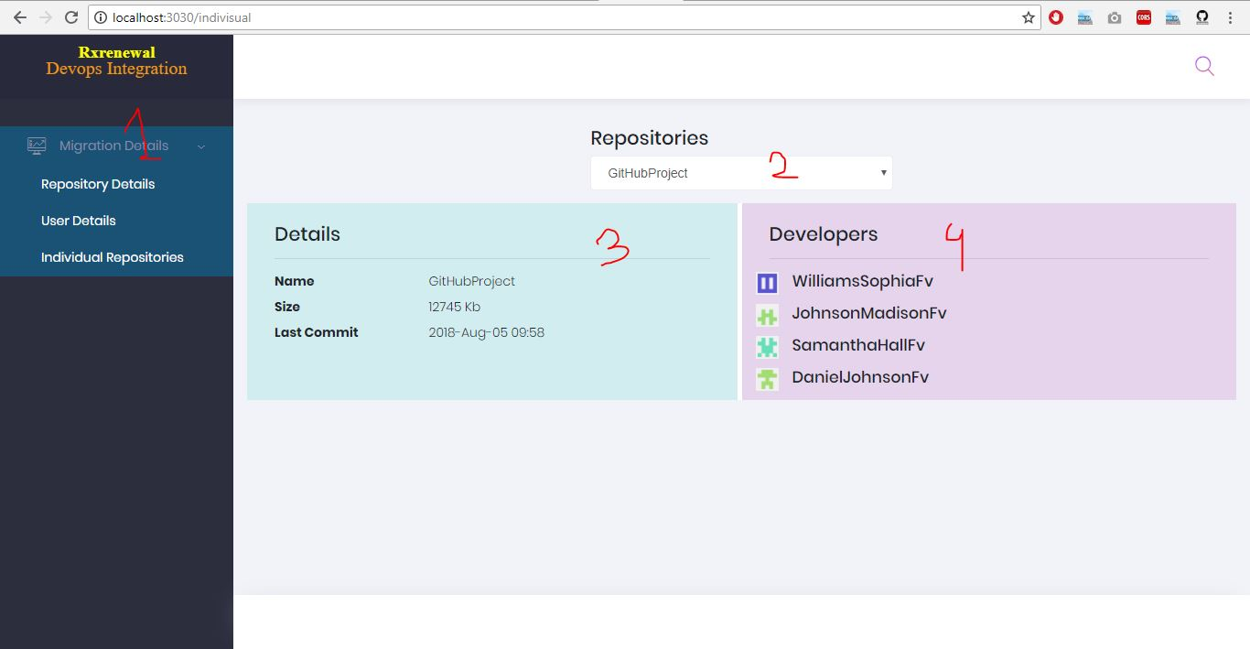

1. Side menu
2. Dropdown for all repository.
3. Details of selected repository.
4. Team members of selected repository.